|  |  |
| --- | --- |
| Single Page Application on Online shopping  MEAN FSD 8 Hour Code Capsule | Abstract  Online Shopping Application is a Single Page Application (SPA) that allow the Users to buy or sell the Items of their choices.  Developer  MEAN Full Stack Developer |

# Business-Requirement: An Overview

**The Online Shopping Application** allows user to view and order the items based on the Categories of the items which are updated by the Seller based on the availability of the product. Admin will have the control on all orders and items list**.** Below are the features of Online Shopping Application:

**User:**

* Registration:
* Login:
* Forgot password:
* Update details:

**Payment:**

* Pay upi:
* paytm:
* Gpay:
* COD:

**Order:**

* Place order:
* Cancel order:
* Update order:

**Admin:**

* Block user:
* Block seller:
* Deny order:

**Items:**

* Add items:
* Edit items:
* Remove items:
* View items:

1. **Home Page:** Default home  page for all the users, including guest users. Items can be viewed according to the categories, but can be added to cart only after login.

Home page contains Drop down menu to select login, sign-up, view profile, logout options through which different user accounts- Buyer, Seller and admin accounts can be accessed.

1. **Sign-up page:** Buyer and Seller have different sign-up pages having different required information and also a button to switch from one user sign-up page to another.

1. **Login Page:** Login page contains input tabs for email and password, which will be validated and redirected on submission to:

* Home page if user is Buyer
* Seller Page if user is Seller
* Admin page if user is admin

1. On the Home page after login, User can select a category under which they need the items to be displayed. Each item will be displayed along with item image, item name, price and a button- add to cart below it. When the add to cart button is clicked, that particular item will be added to the cart.

1. **Cart Page:** Cart page contains the list of all the items added to the cart along with the options of cancelling an item, and increasing or decreasing the number of products. This page also contains an invoice showing the total payable amount of the cart, including tax and discounts. Payment page can be accessed by clicking the ‘ **purchase now‘** button.

Users can go back to the home page or logout by clicking buttons assigned respectively.

1. **Delivery address Page:** To enter or update the address to which the purchased item should be delivered. This page also includes an update of mobile numbers for contact purposes.

1. **Payment Page:** This page consists of all the payment options available to purchase the item.

In Payment section the user can select the payment mode they prefer:

* Cash on Delivery
* UPI payment
* Card Payment
* Paytm

User can confirm and place the order if COD is selected by clicking ‘Confirm order’ button or will be redirected to payment gateway page, if selected any other payment method.

User can go back to cart page by clicking ‘cancel’ button, or to home page by clicking ‘home’ button.

1. **Profile page:** User can access their profile page by selecting ‘Profile’ from the drop down menu on the home page.

Profile page displays the user information and the links to edit user information along with other options such as:

* Change password
* Your order

1. **Your Order:** This page contains all the order placed by the user including the already delivered order. In the future version we are planning to have an option of canceling and tracking these orders.

1. **Product Page:** This is an item view page, which displays all the details of the item clicked by the user in the homepage. It also has options to add to cart only if the user is logged in.

1. **Admin Page:** This is the page displayed when the admin is logged in. It has links for all the features admin has access to:

* List of orders
* Manage order- Accept, decline or update order
* Manage Users- Block buyer or seller
* Manage Items- Add, Edit or Remove item
* Manage feedbacks and reports.

1. **Seller Page:** This is the page displayed when the seller is logged in. It has links for all the features seller has access to:

* List of orders seller has got
* Seller profile
* manage item created by seller- Add, edit or remove item

1. **Add or Update item page:** This page is to add new item. this page can be accessed by admin and seller. In case of editing the item, the details of the items will be pre-filled, and the user can change any field as required except for product id.

1. **Forgot Password Page**
2. **Change Password Page**

# Technical Spec –Solution Development Environment

## Front End Layer

|  |  |
| --- | --- |
| **Framework(s)/SDK/Libraries** | **Version** |
| Angular | 1.5 or above |
| Bootstrap | 3.0 or above |
| CSS | 3 |
| HTML | 5 |
| JavaScript | **1.8 or above** |
| JQuery | **1.3** |

## Middle Tier Layer

|  |  |  |
| --- | --- | --- |
| **Technology** | **Framework(s)/SDK/Libraries** | **Version** |
| MEAN Stack | Node.JS | 6.x (Latest: 6.11.4) |
| Express.JS | 4.16.1 |

## Database & Integration Layer

|  |  |  |
| --- | --- | --- |
| **Technology** | **Framework(s)/SDK/Libraries** | **Version** |
| MEAN Stack | MongoDB/MySQL |  |
| NoSQL |  |
| Mongoose.JS | 4.12.1 |

## Ancillary Layer

|  |  |  |
| --- | --- | --- |
| **Technology** | **Framework(s)/SDK/Libraries** | **Version** |
| Source Code Management Tool | GIT | 2.14.2 |
| Build Tool/MEAN Stack | Grunt/Gulp | 1.0.1/3.9.1 |
| Dependency Management Tool/MEAN Stack | NPM | 4.x |
| Testing Tool/MEAN Stack | Jasmine |  |

## Deployment & Infrastructure

|  |  |  |
| --- | --- | --- |
| **Technology** | **Framework(s)/SDK/Libraries** | **Version** |
| Docker | - |  |
| Apache HTTP (XAMPP) | - |  |
| Node | - |  |
| Dependency Management Tool | NPM |  |

## Editors

|  |  |
| --- | --- |
| **Name** | **Version** |
| Adobe Brackets |  |
| Sublime Text |  |
| Atom Editor |  |

# Wireframes

**User SignUp page for buyer sign-up**

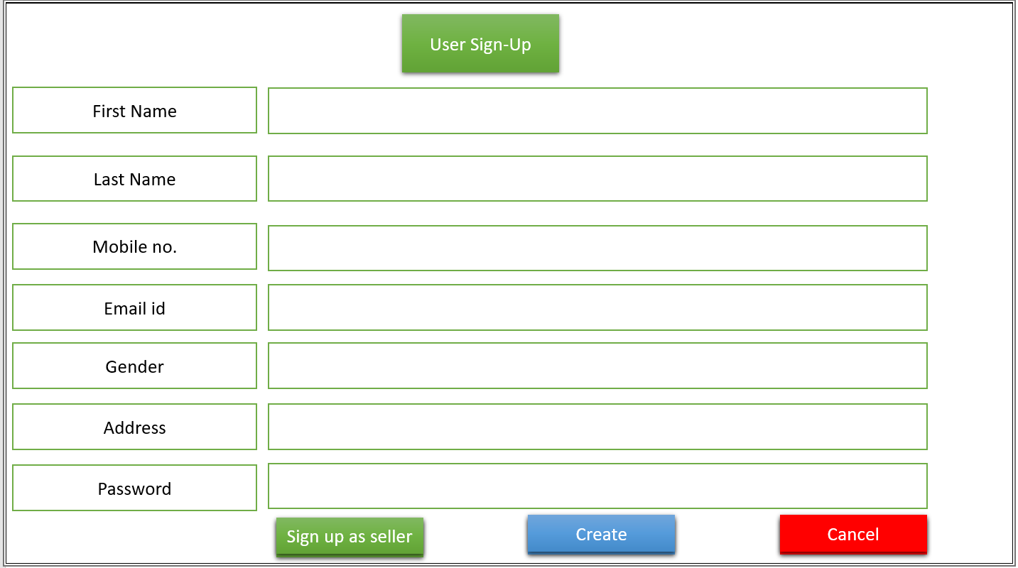

**User Signup page for Seller sign-up**

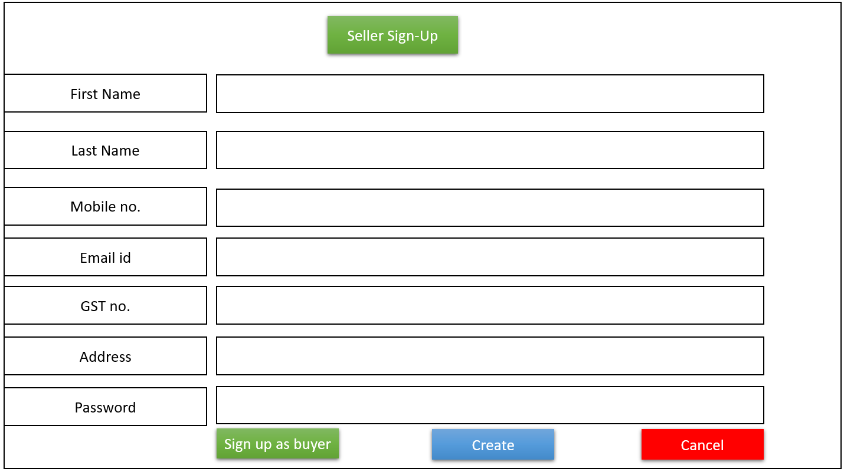

**User Login page**

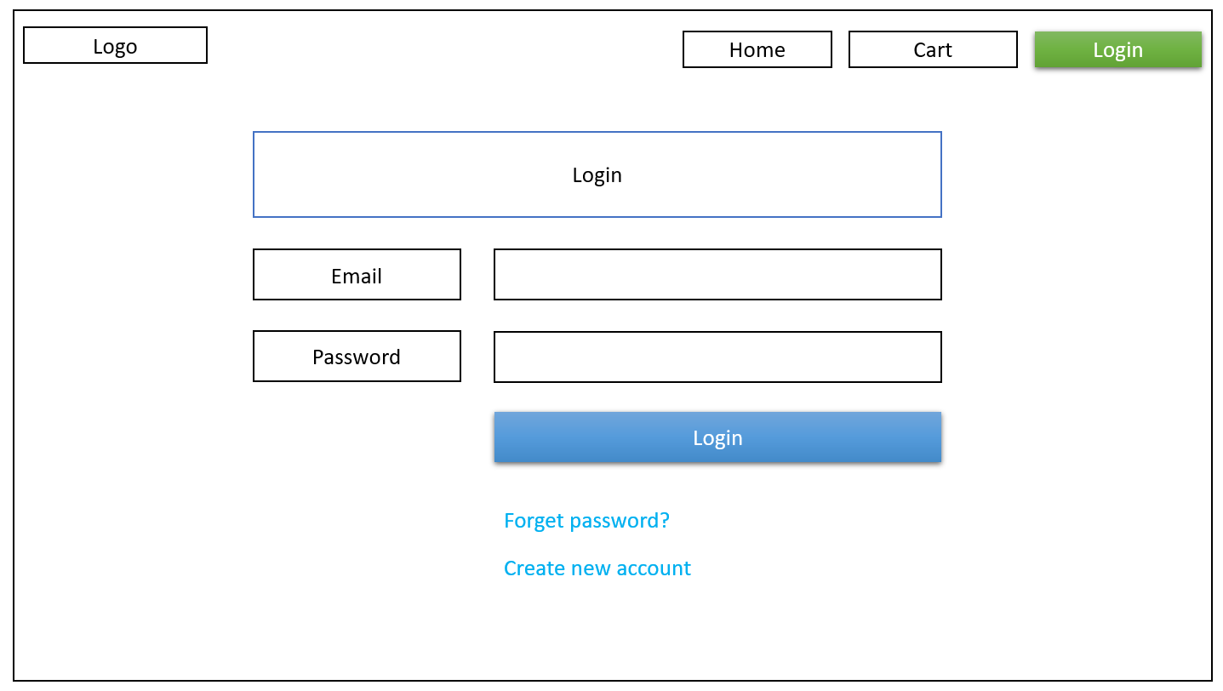

**Add or edit Item:** item details will be entered by default in case of edit item, and can be edited.

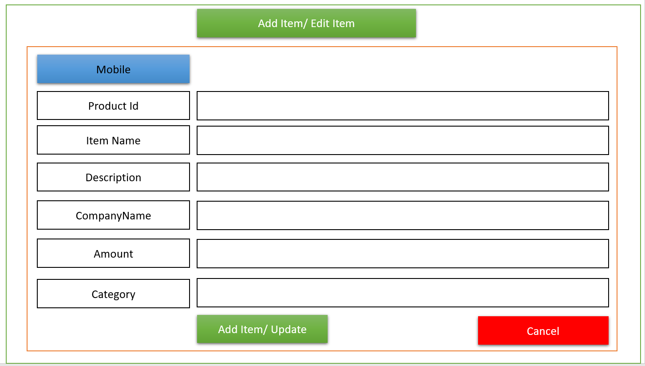

**Home page-** Default page for guest users. 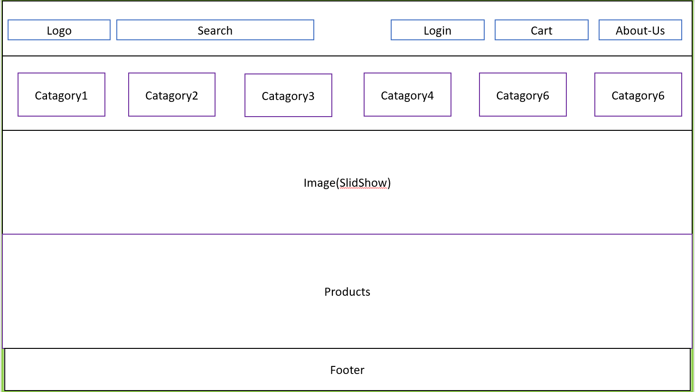

**Item View Page:**

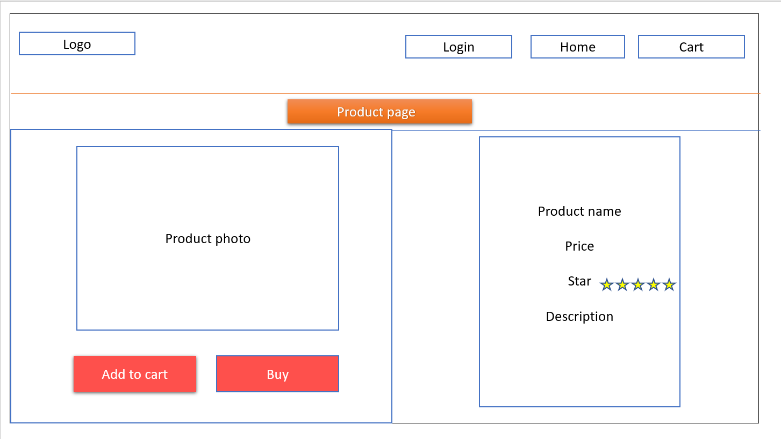

**User Profile page**

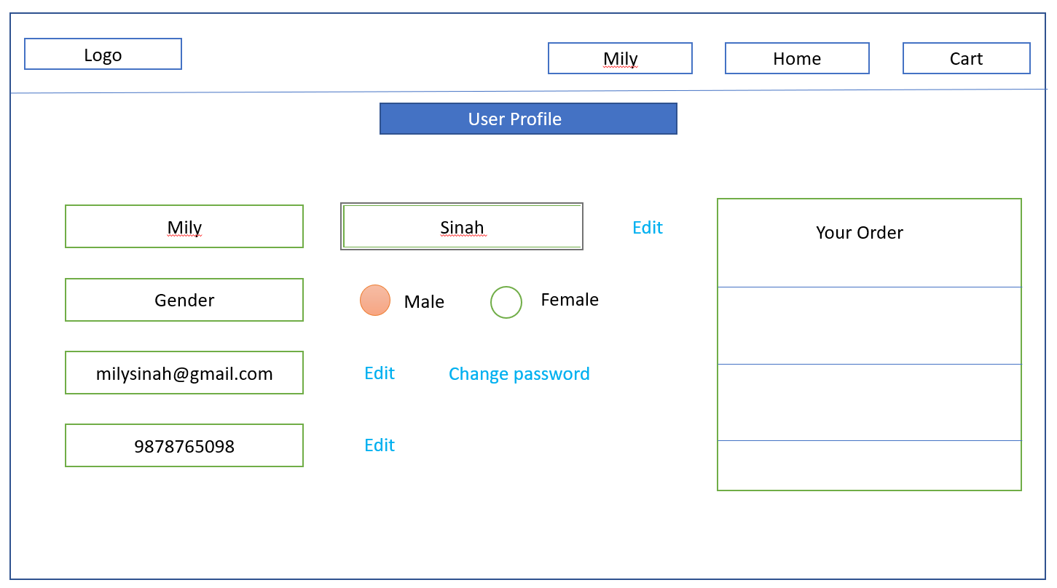

**User’s Your order page**

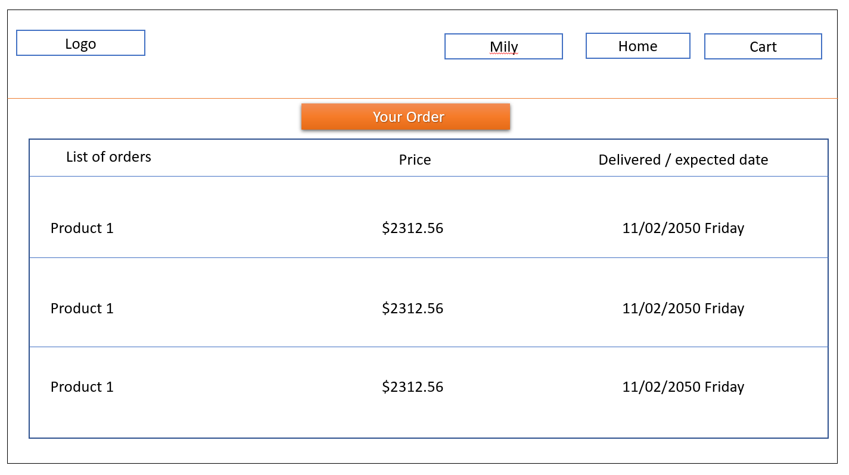

**Cart Page:** After clicking add to cart button below the items, the item will be added to cart, here user can confirm the items to be purchased.

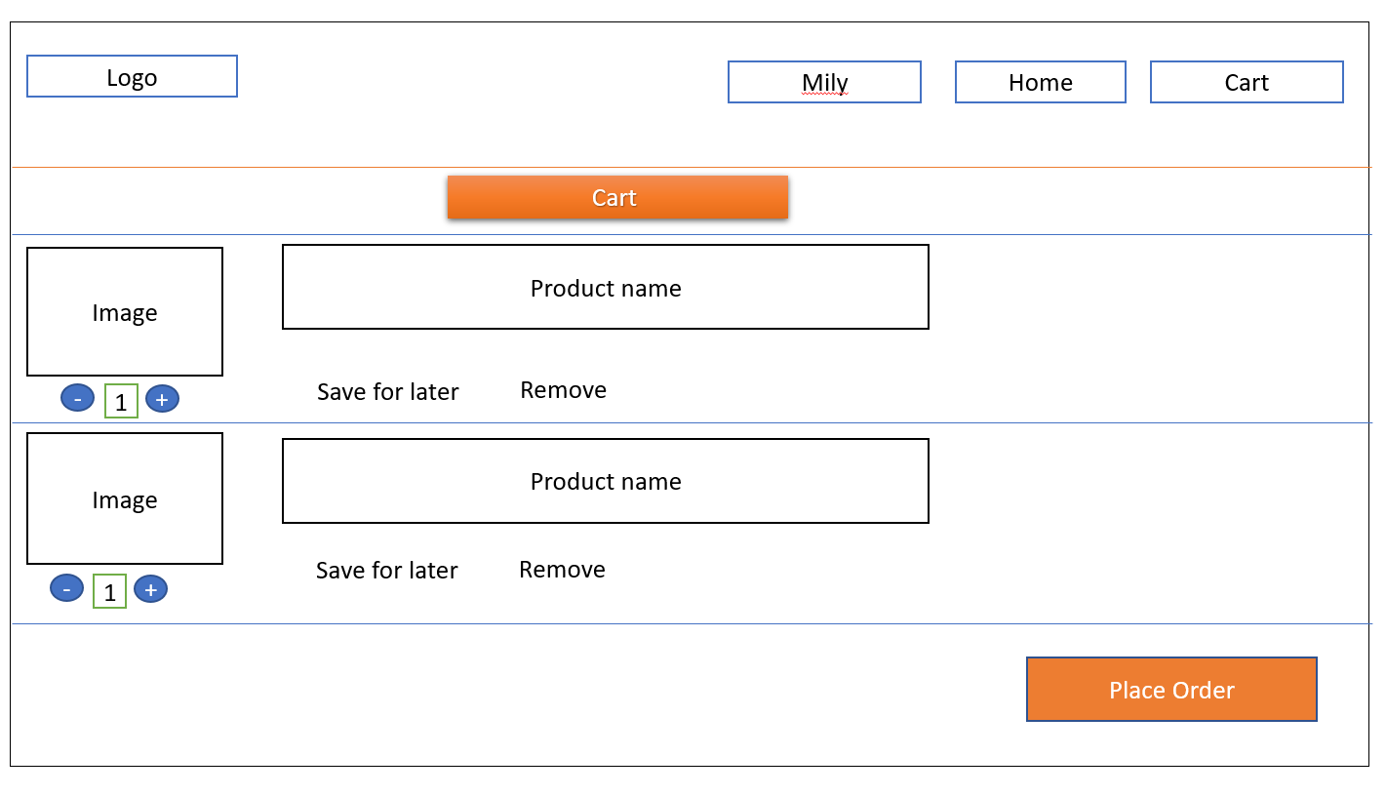

**Payment and Delivery details page**

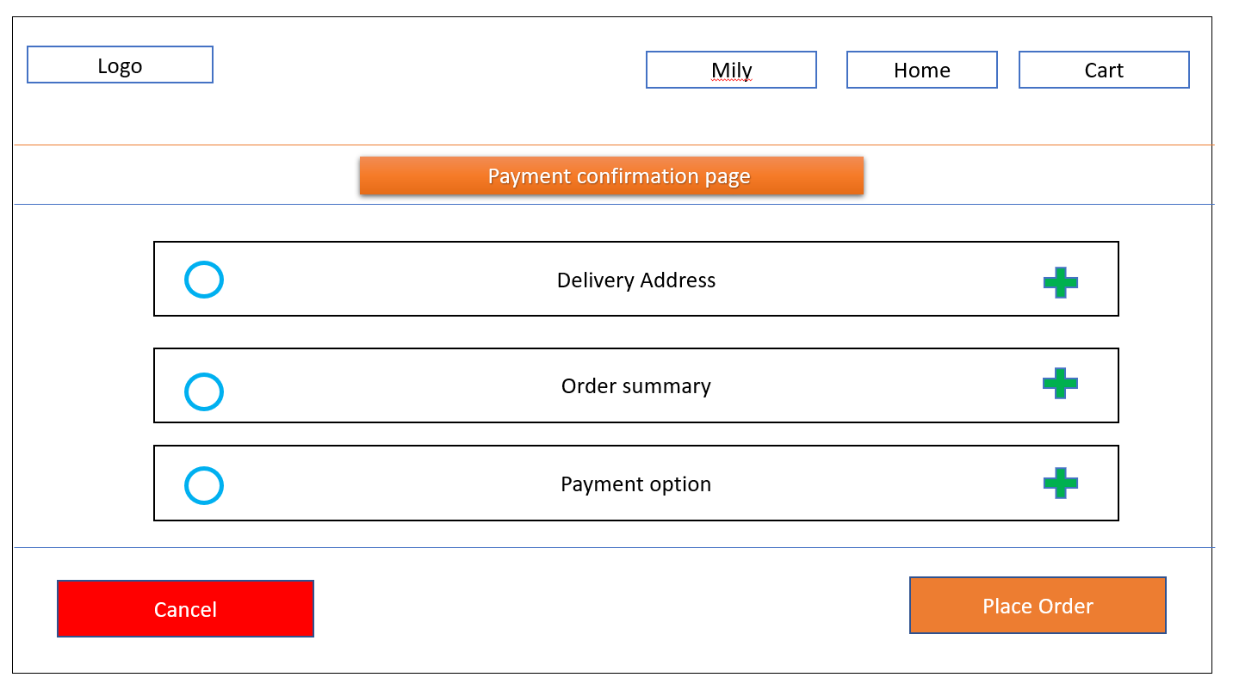

**Delivery Address page:**

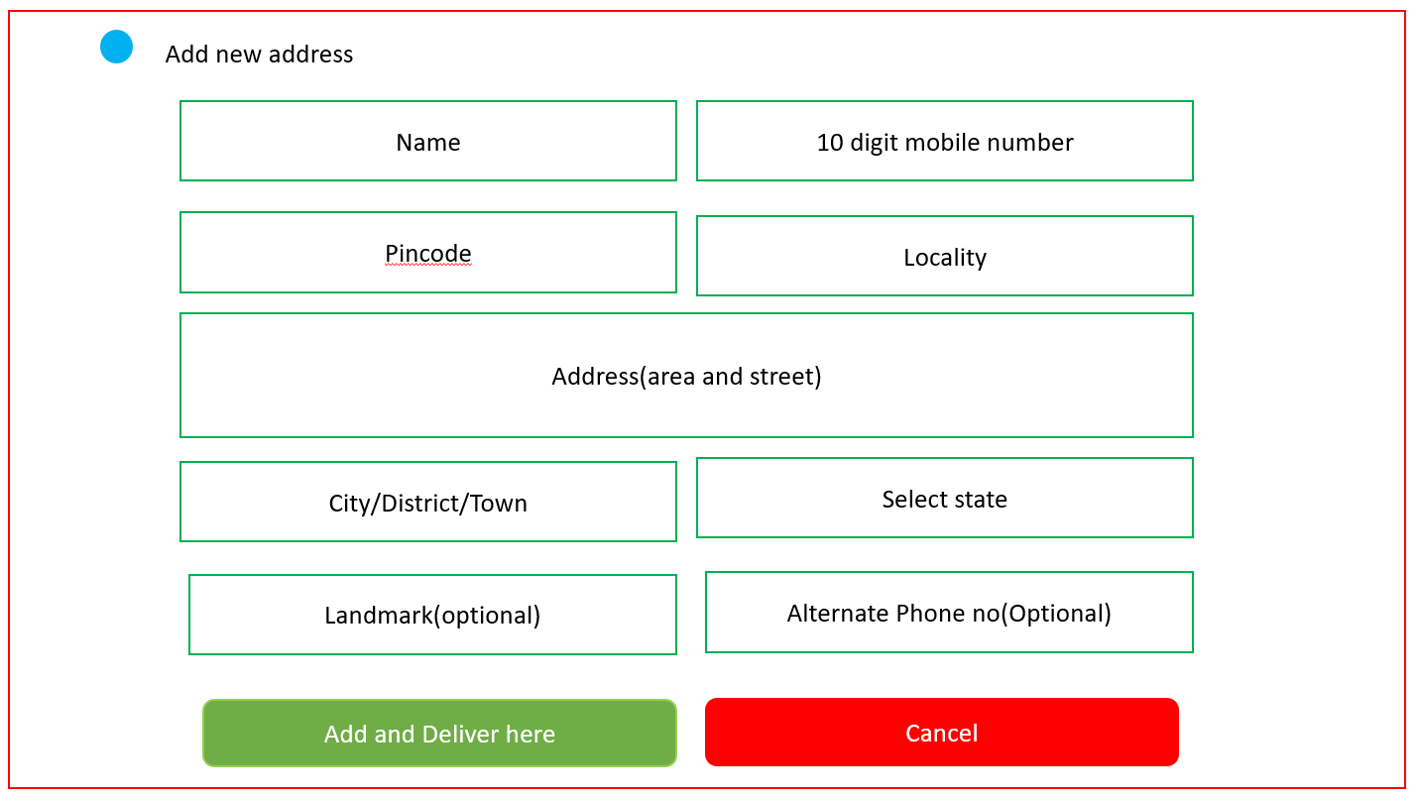

**Payment method page:**

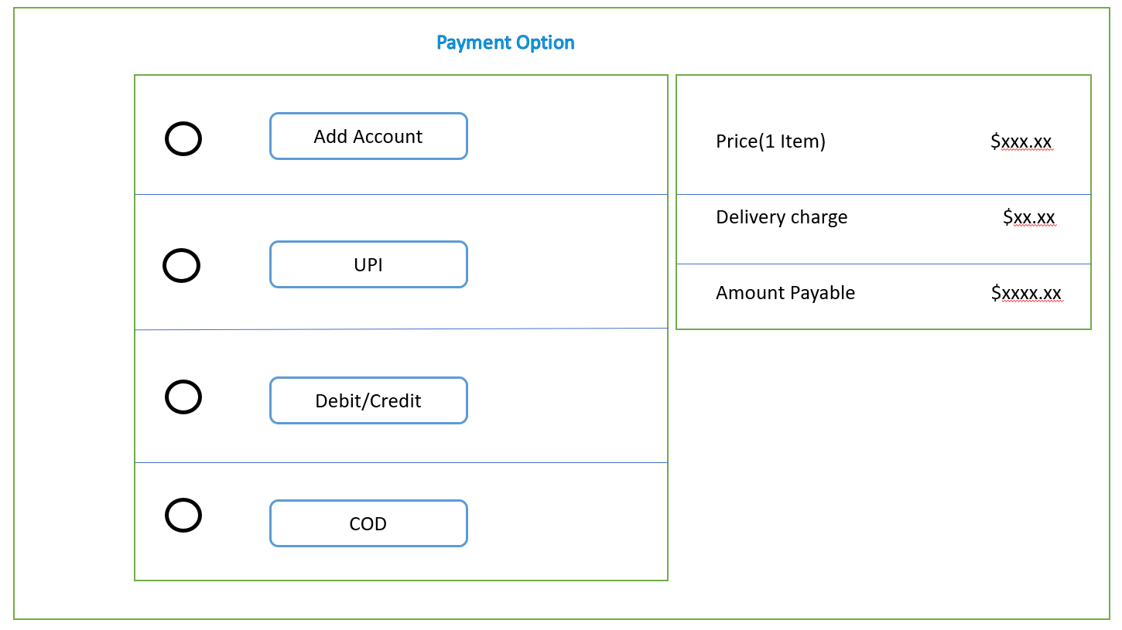

**Admin page:** after login as admin.

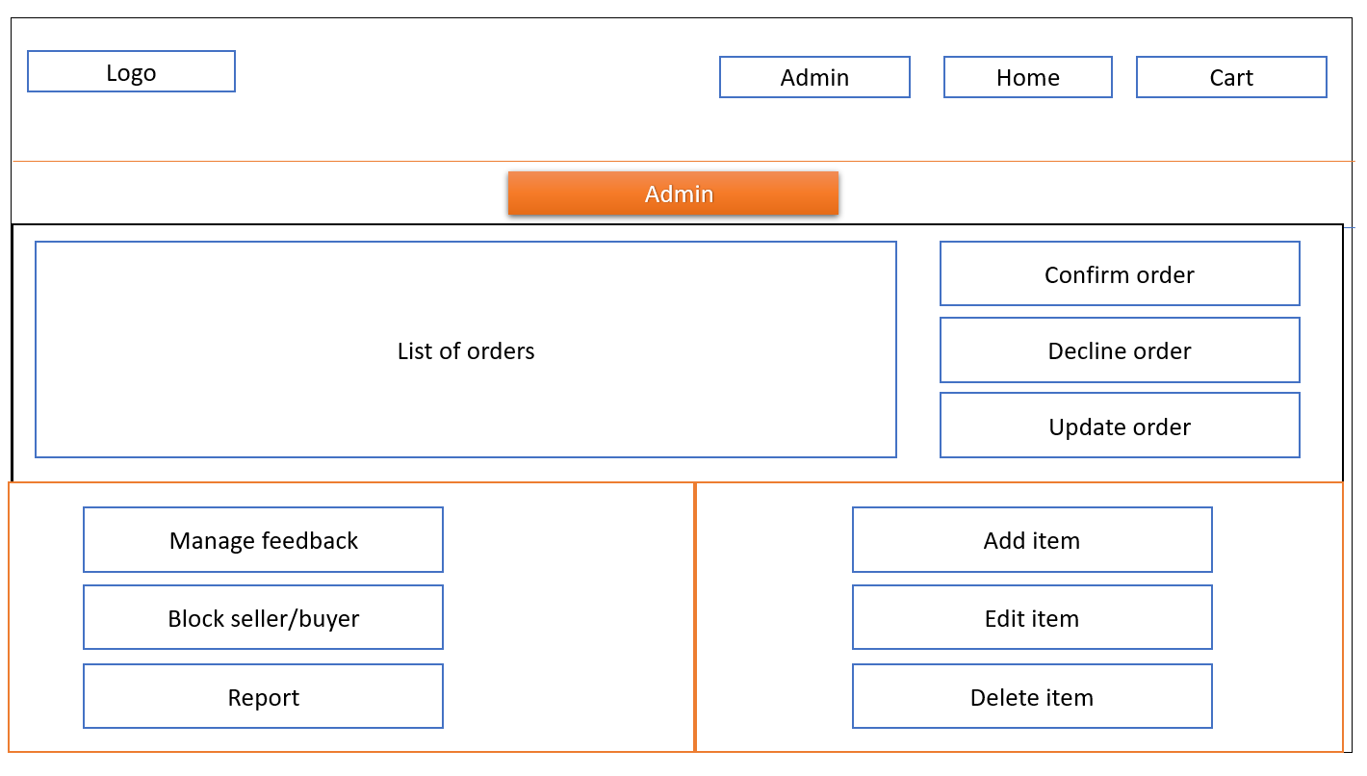

**Seller Page:** After login as seller.

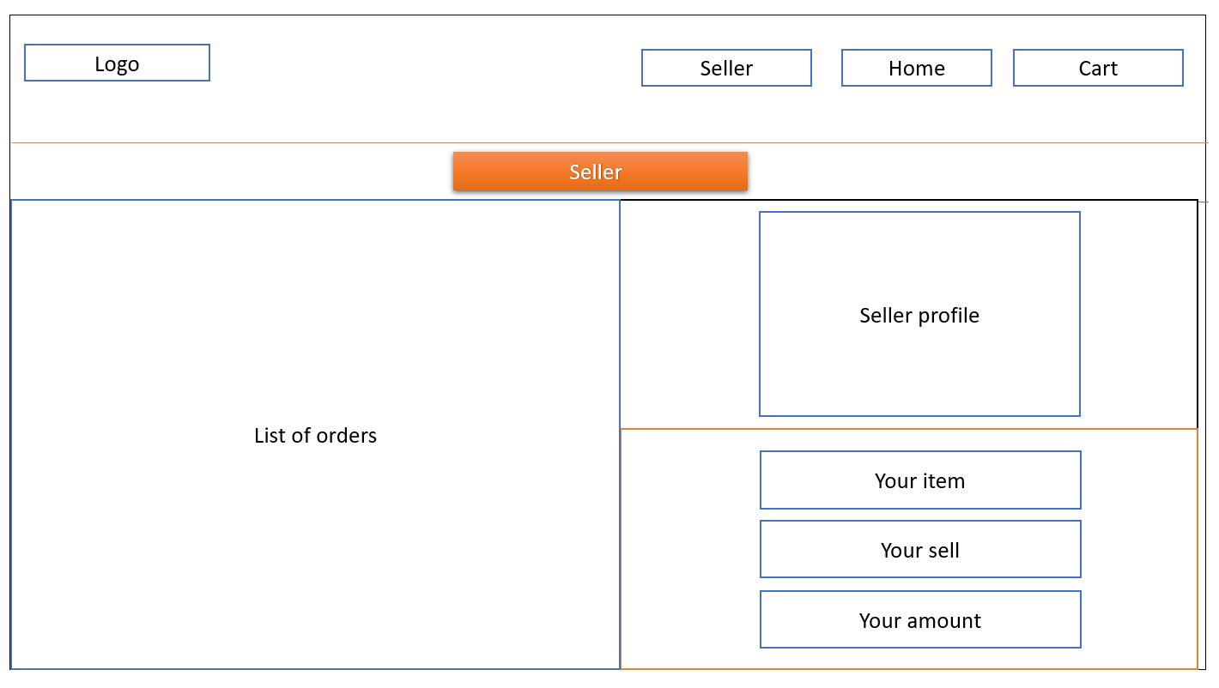

**Change and Forgot password pages:**

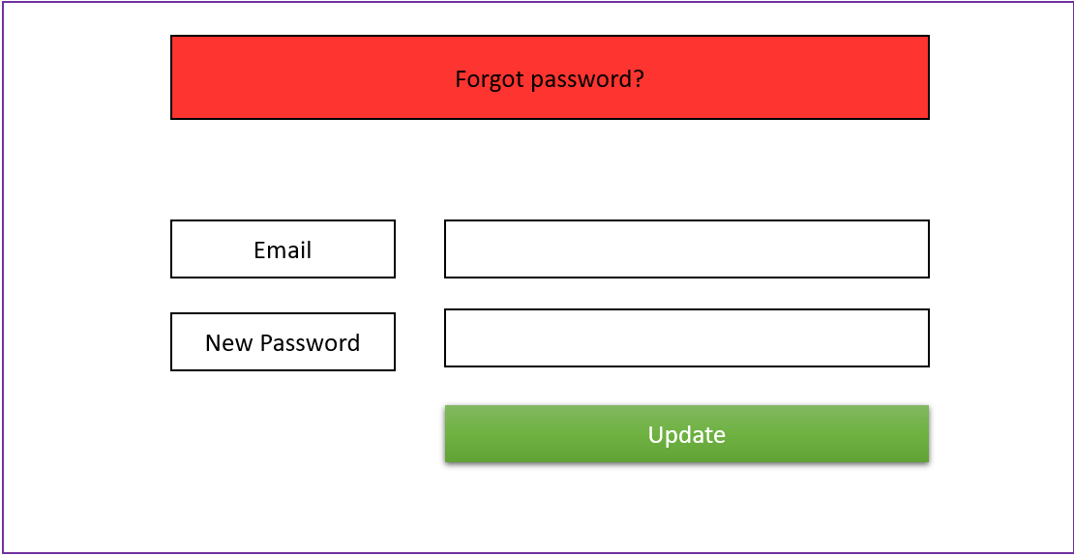

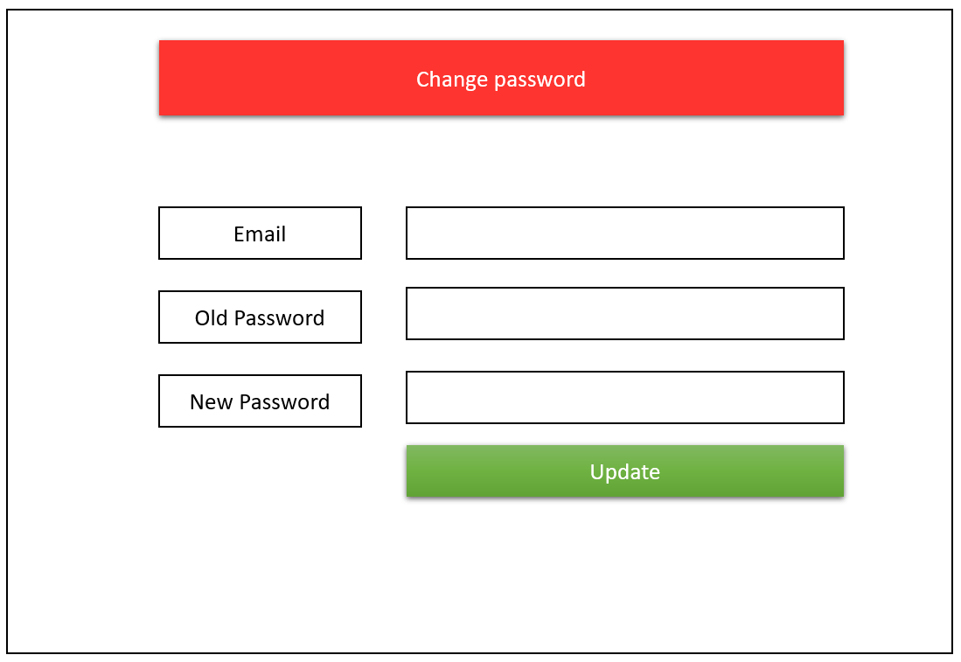

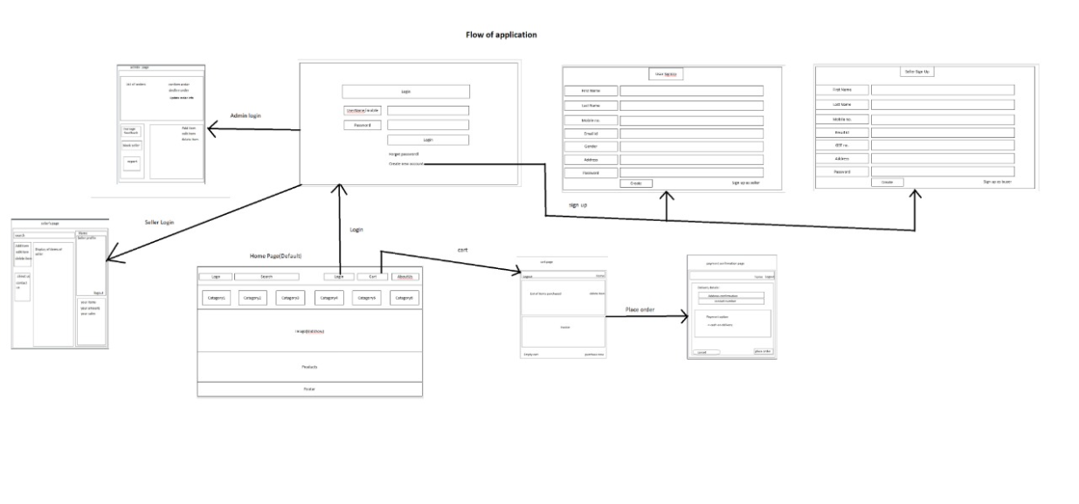

**Flow chart of the Features:**



        
        
        
        